**Taking backup local EC2 database to an AWS RDS instance using MariaDB**

**Step1:** Log in to the AWS Management Console

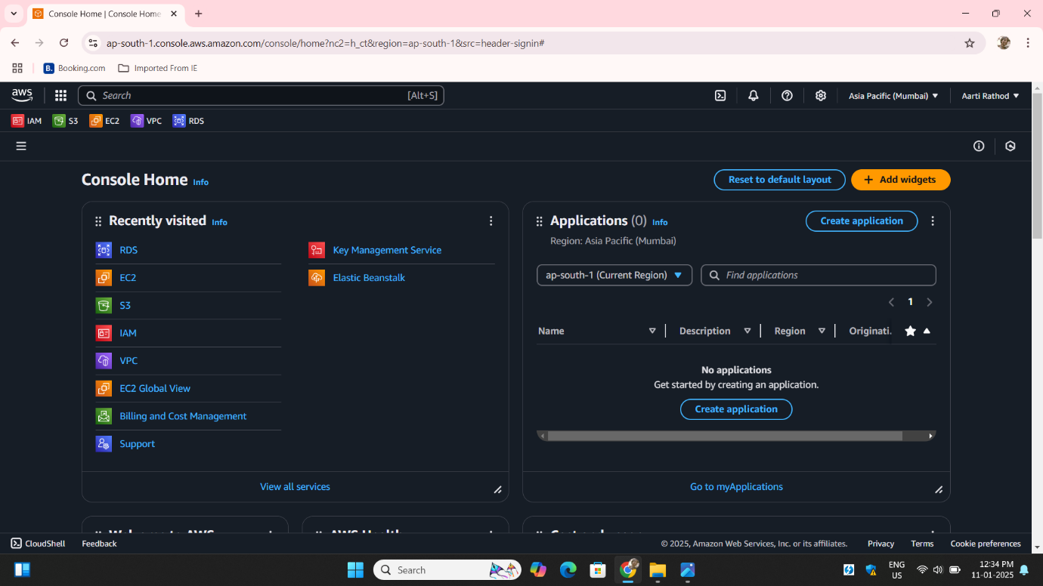

**Step2:** Navigate to the **RDS** service:

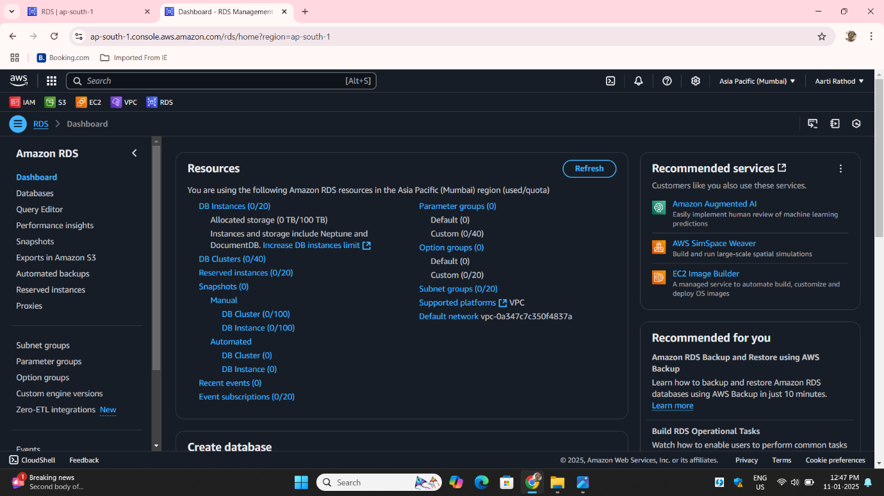

**Step3**: Click on **Create database**:

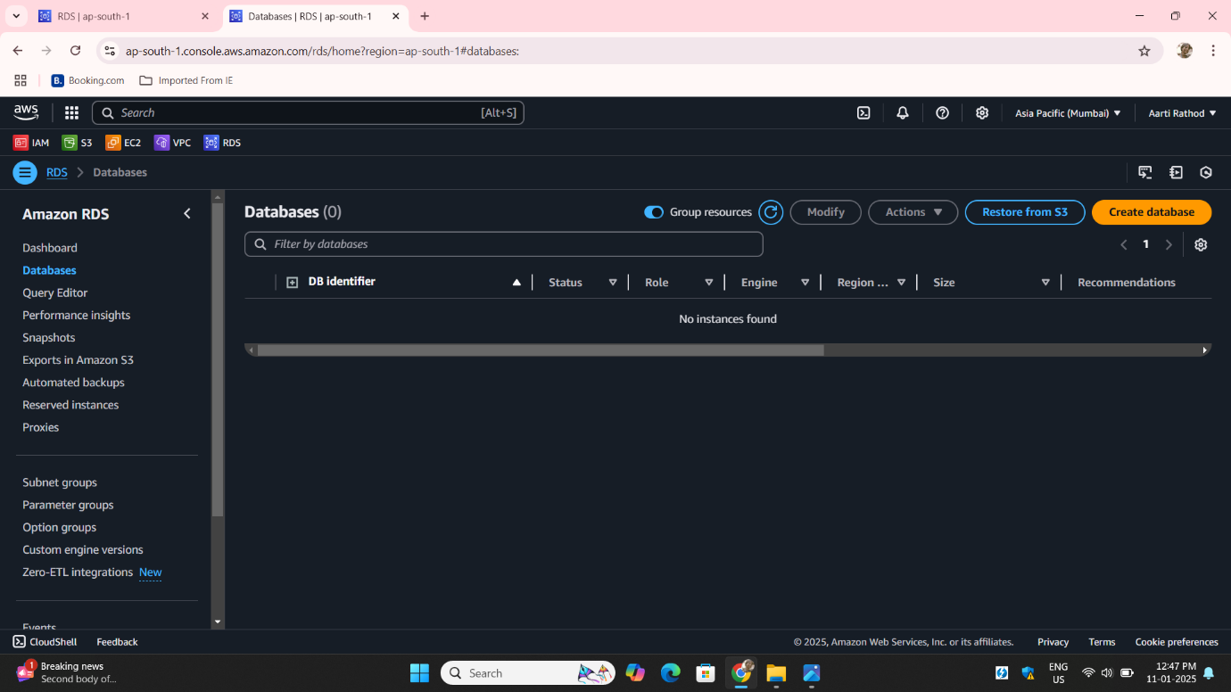

**Step4**: Select **Standard create** for more control over settings:

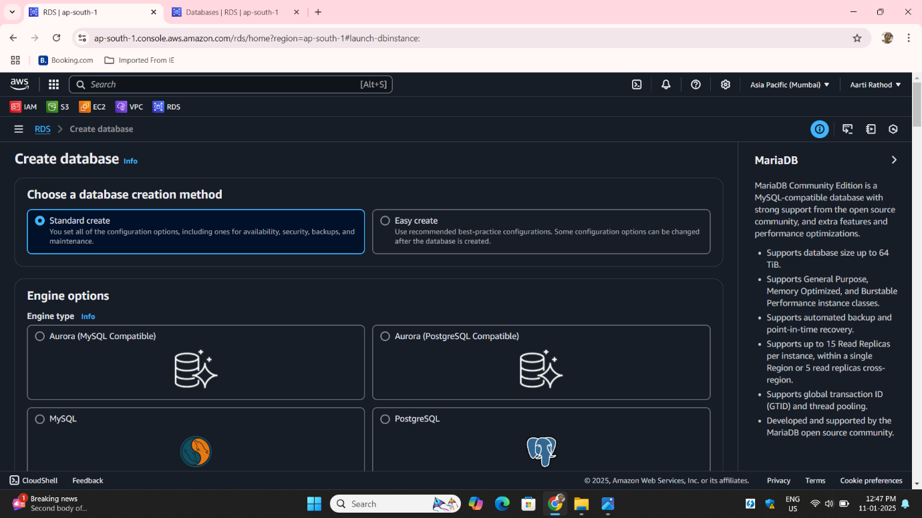

**Step5:** Choose your database engine **MariaDB:**

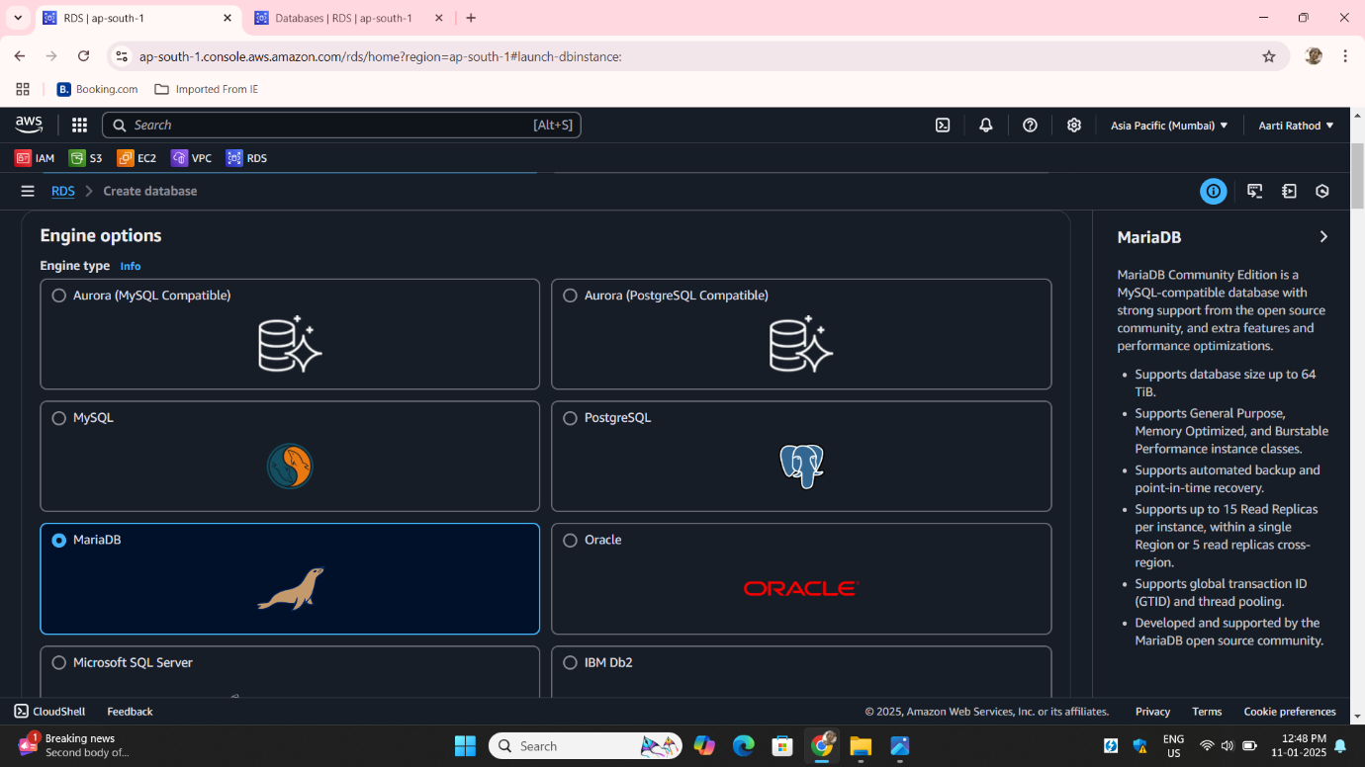

**Step6: Choose Engine Version**: Select the required version.**Choose Templates**: Choose Production for realibity, scalability.

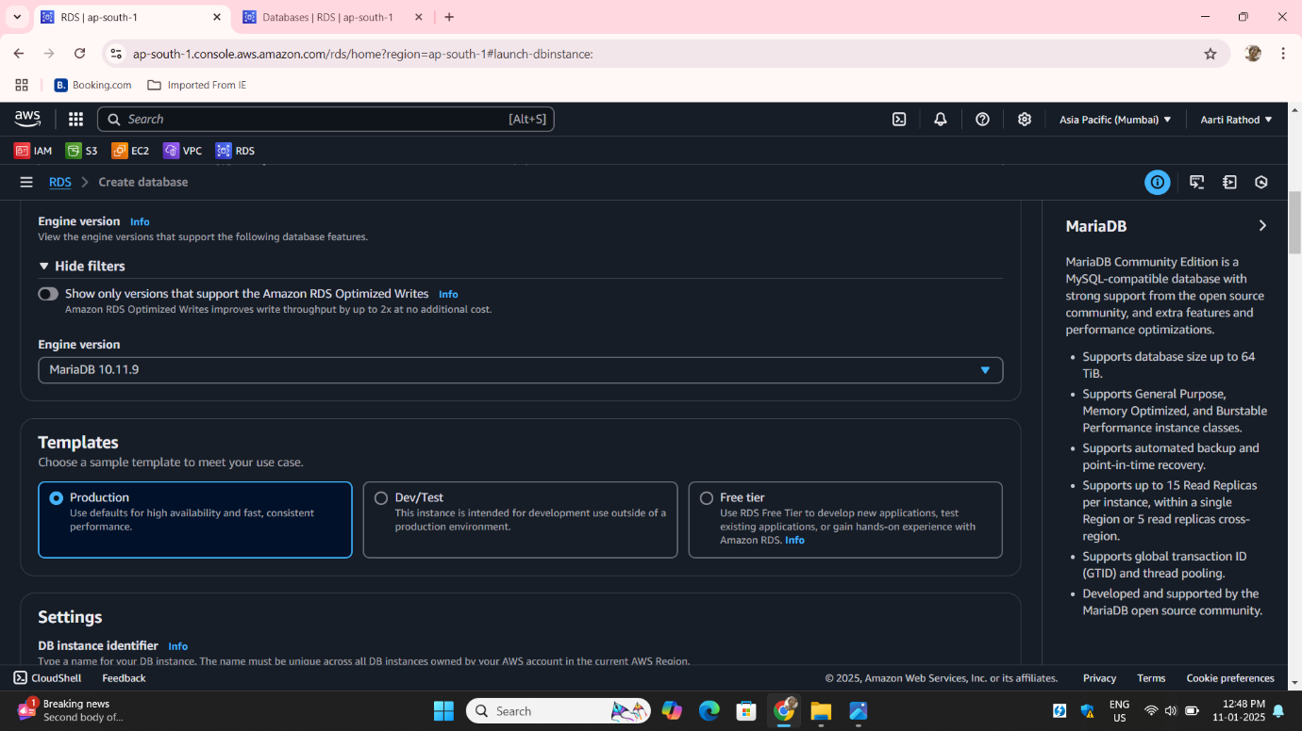

**Step7: DB Instance Identifier**: Enter a unique name for your database **Master Username**: Set the admin username for managing the database.

**Credentials Management**: choose self manage

Select **Auto-generate a password** if you want AWS to create a strong password Alternatively enter your own password manually

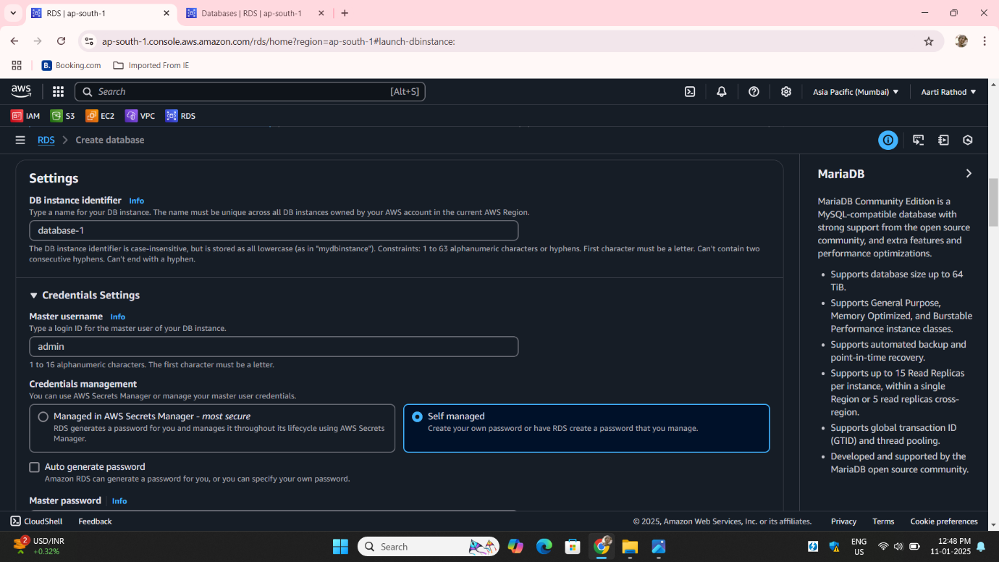

**Step8**: Choose standard classes for cpu and memory for everyday use:

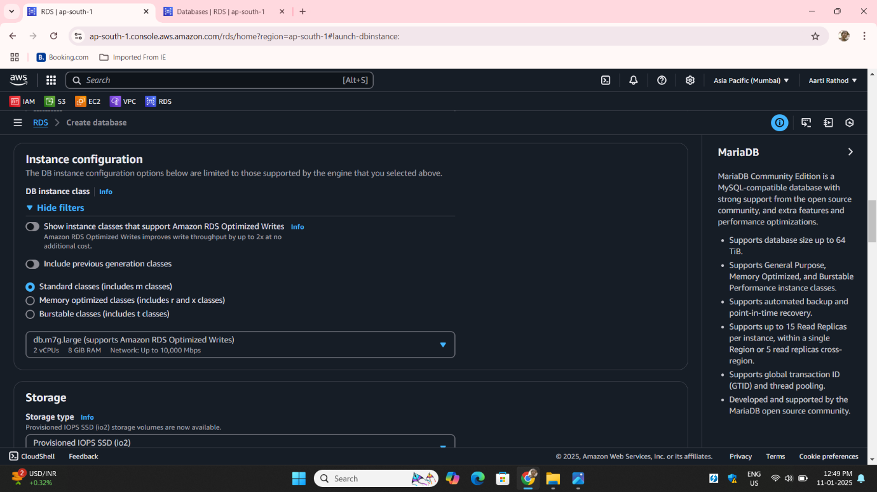

**Step9**: Set the **storage type** General Purpose SSD

Allocate sufficient storage space

Enable storage autoscaling if required

.

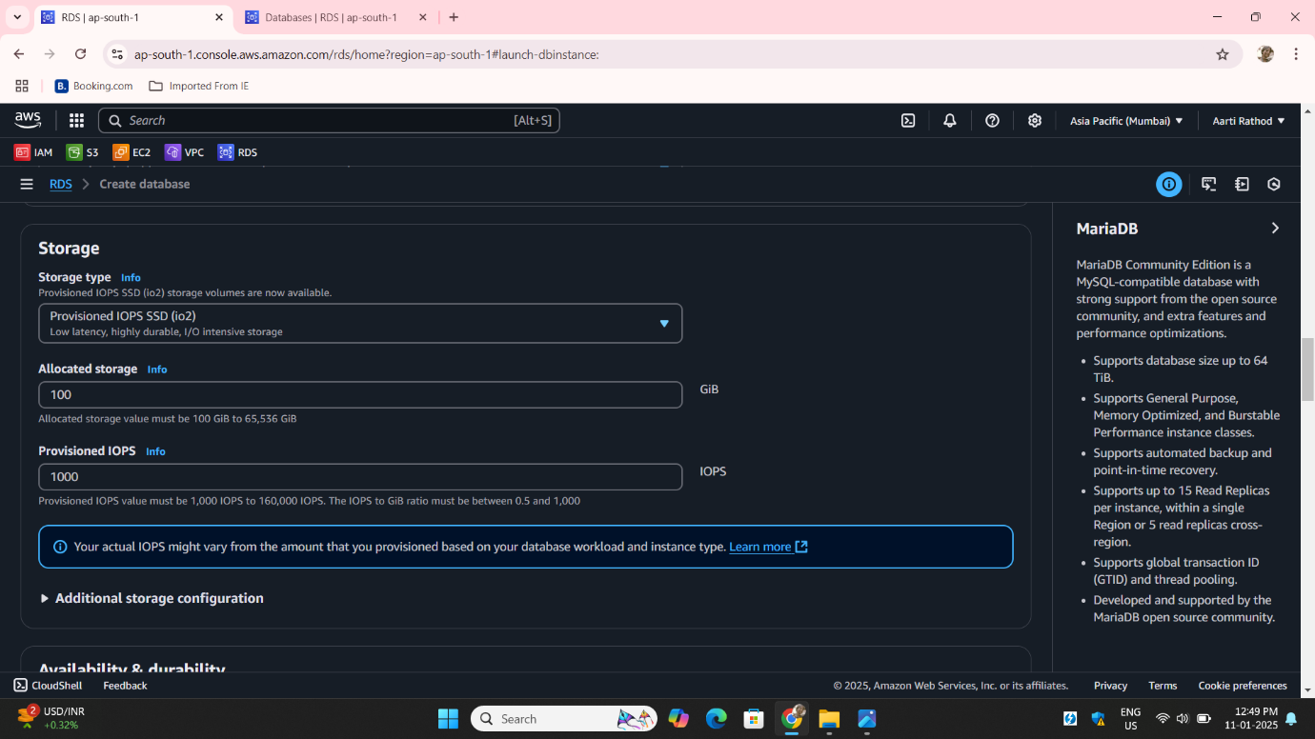

**Step10:** Enable **Multi-AZ Deployment** for high availability.

Create a **standby instace** for a backup to keep your database available if it fails.

Choose Don’t connect EC2 instace compute resource this we will do manually

Choose network type **IPV4** :

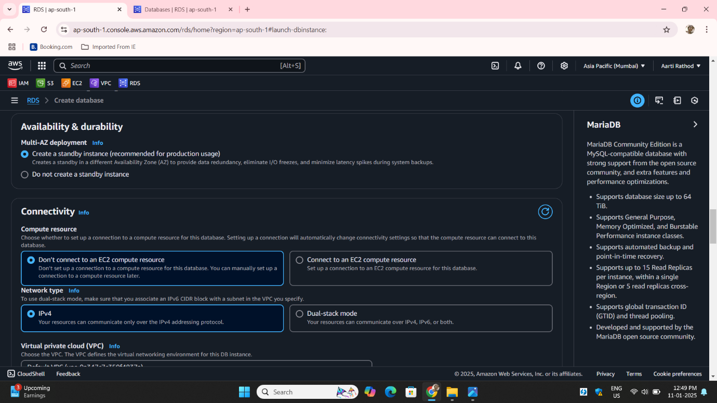

**Step11: VPC**: Select the VPC for the database .**Public Access**: Enable if the database needs external access:

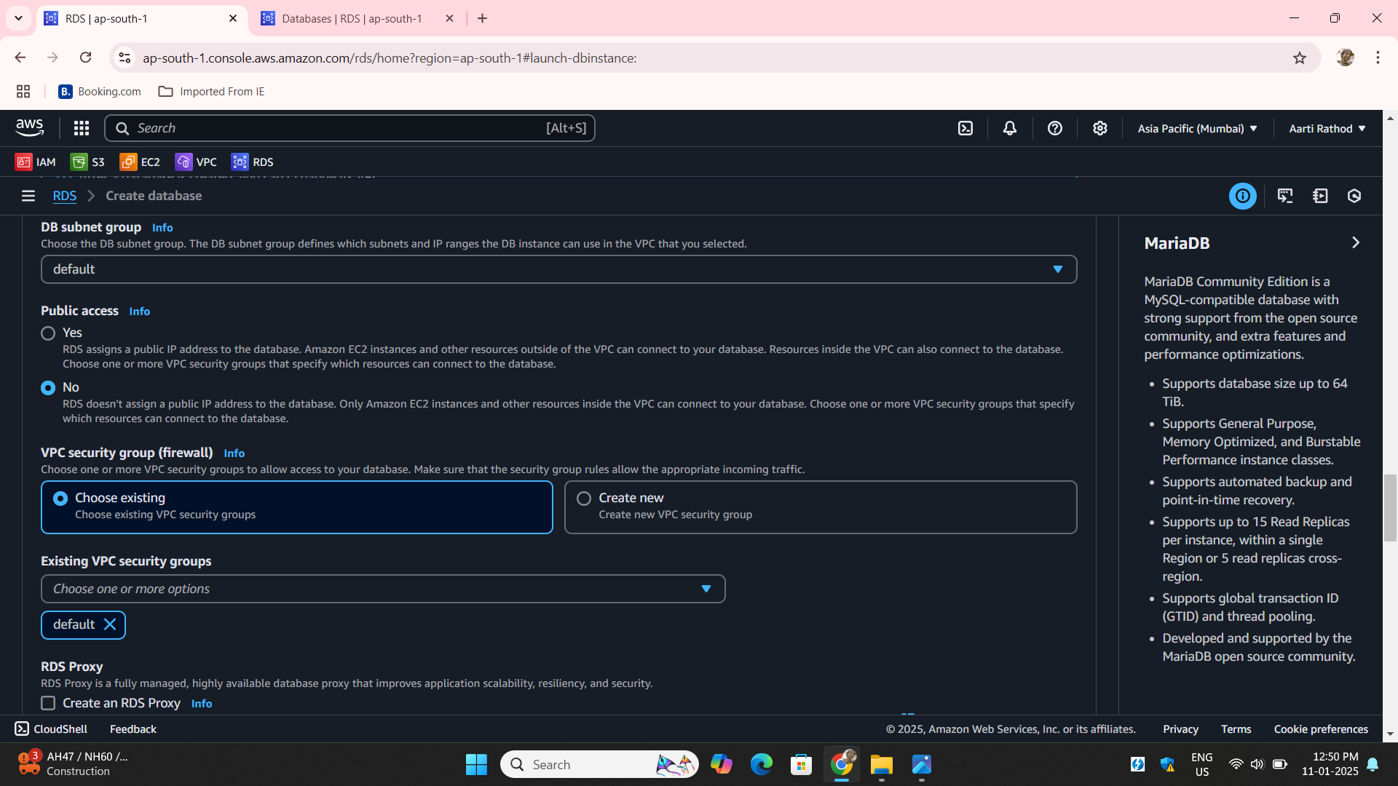

**Step12: Enable performance insights** for track and analyze database performance:

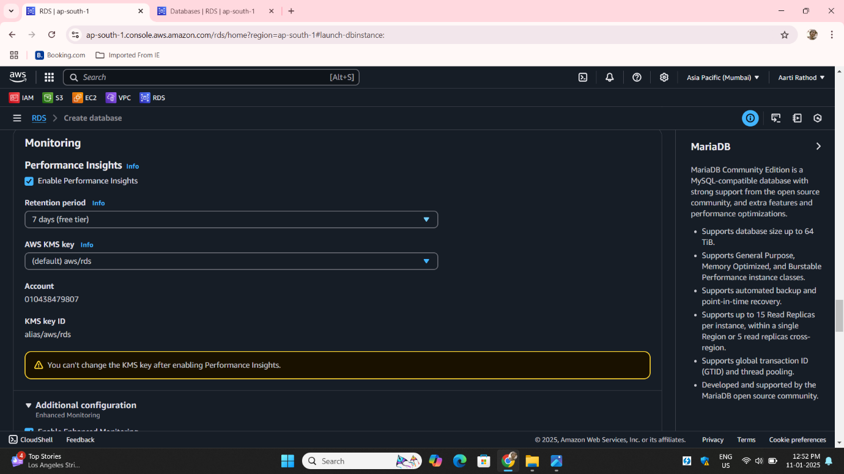

**Step13**: Backup it refers to automatically saving copies of your database to protect against data loss:

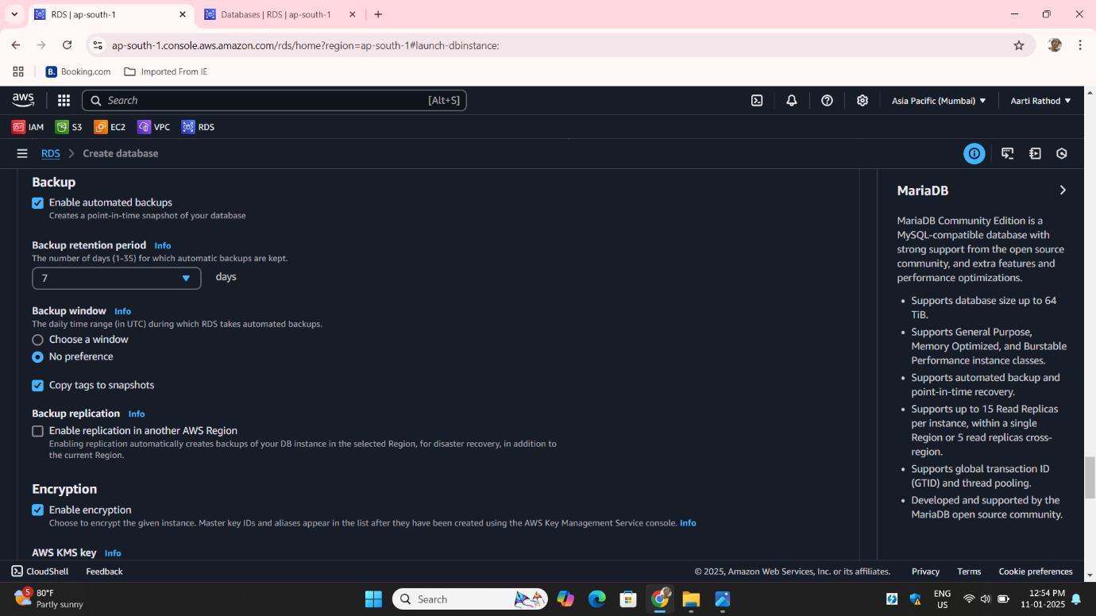

**Step14: Delete Protection** in RDS prevents accidental deletion of your database instance Click on Create database:

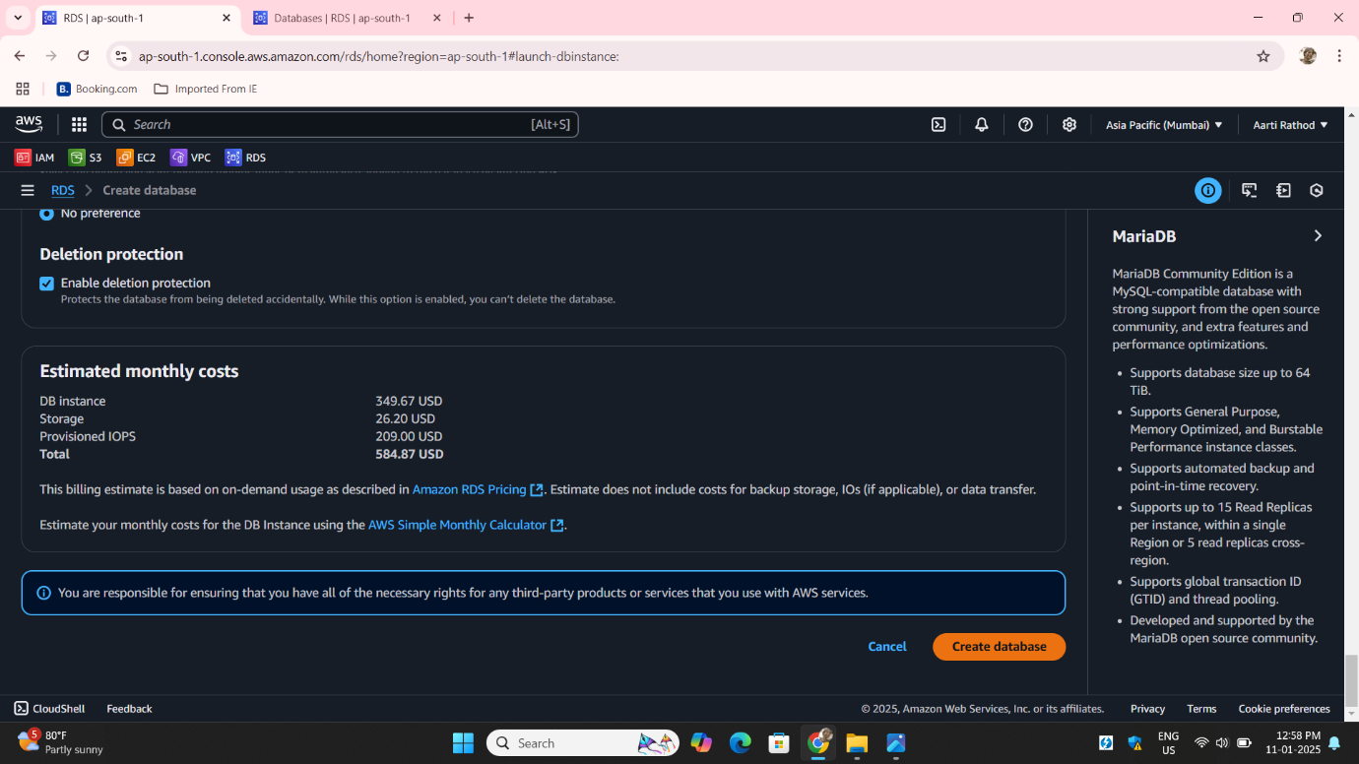

**Step15:** Go to EC2 Dashboard **Launch Instance**: Click on **Launch Instance** to start the creation process.

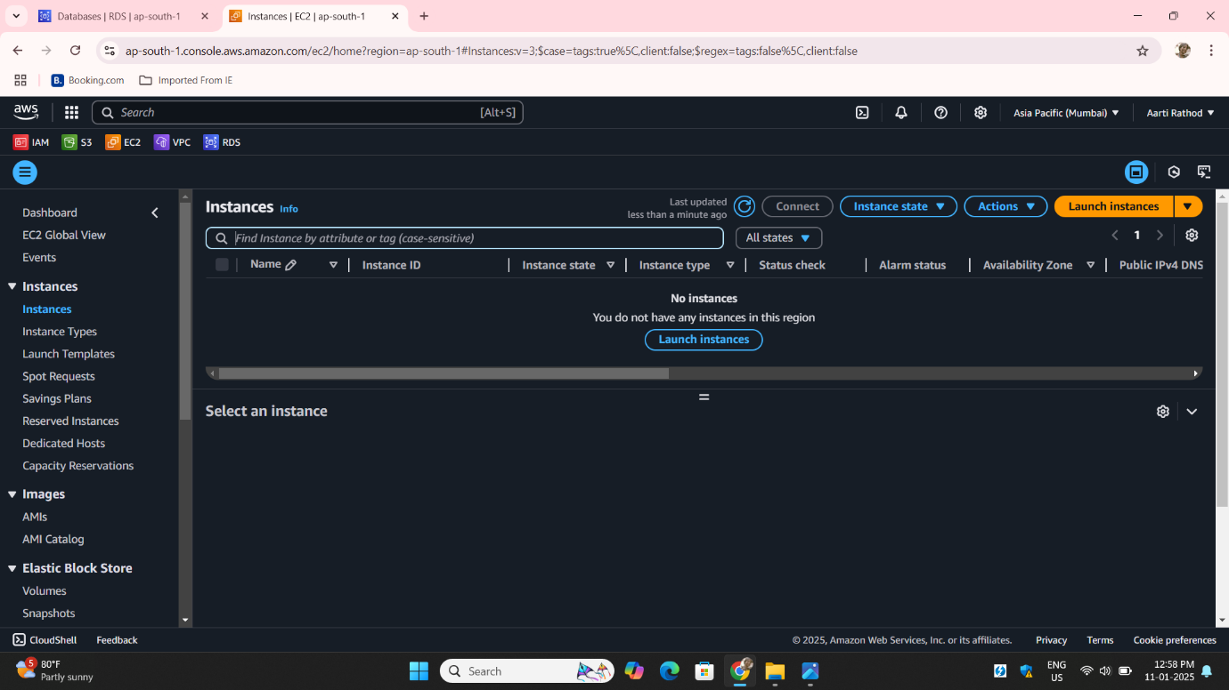

**Step16**: Give a **name Demo** to your Instance

**Choose an Amazon Machine Image (AMI)**: Amazon Machine

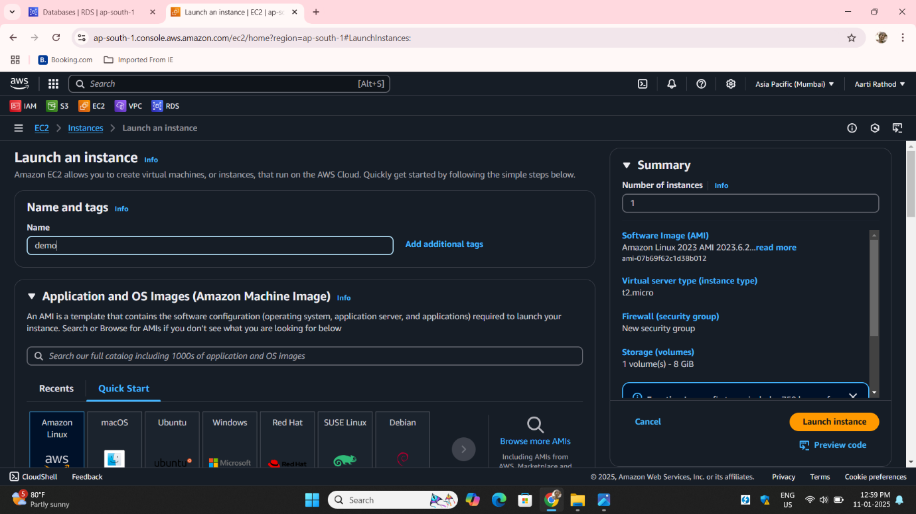

**Step17**: Create **key pair**:

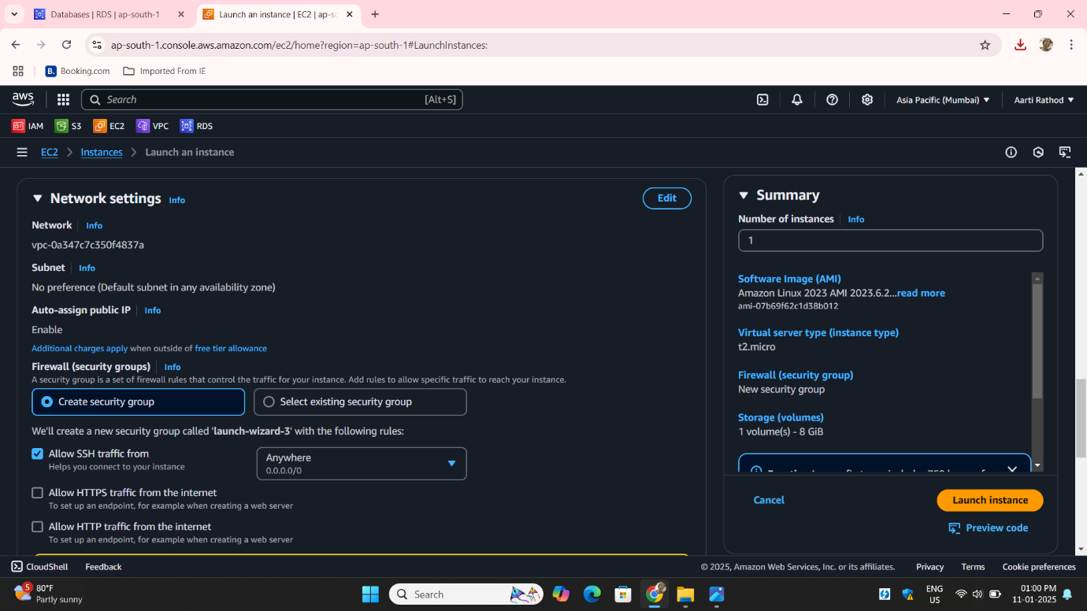

**Step18**: Click on **Launch Instance**

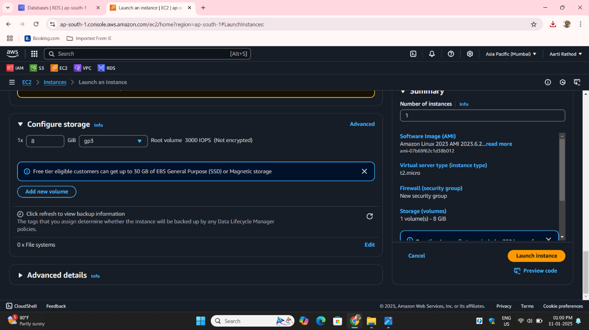

**Step19**: Instance is created go to instance **security Group**:

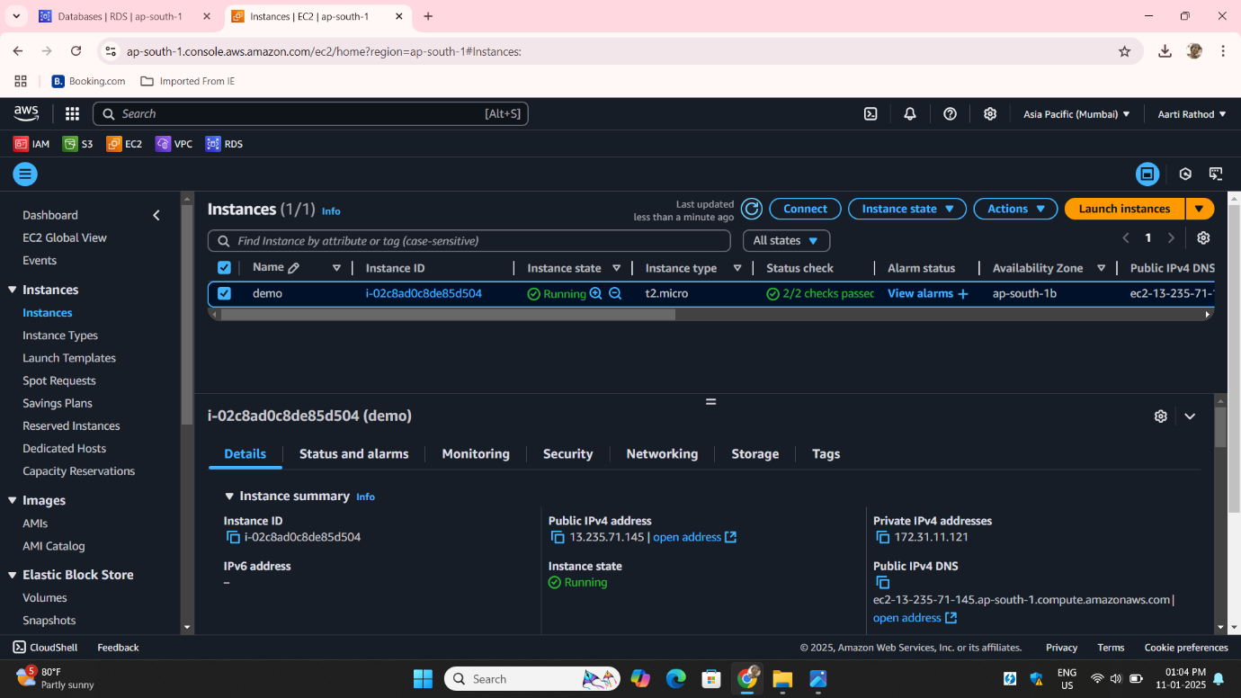

**Step20**: Click on **Edit Inbound Rules**:

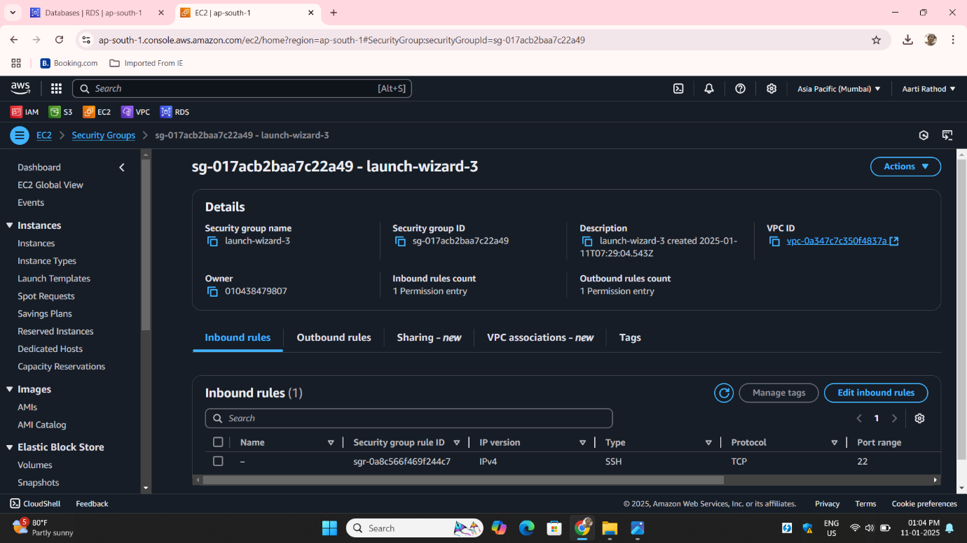

**Step21: Add a Rule for MySQL/Aurora:**

Click **Add Rule**.

Configure the rule as follows:

**Type:** MySQL/Aurora (3306)

**Protocol:** TCP

**Port Range:** 3306

**Source:** Anywhere

Click **Save Rules** to apply changes.

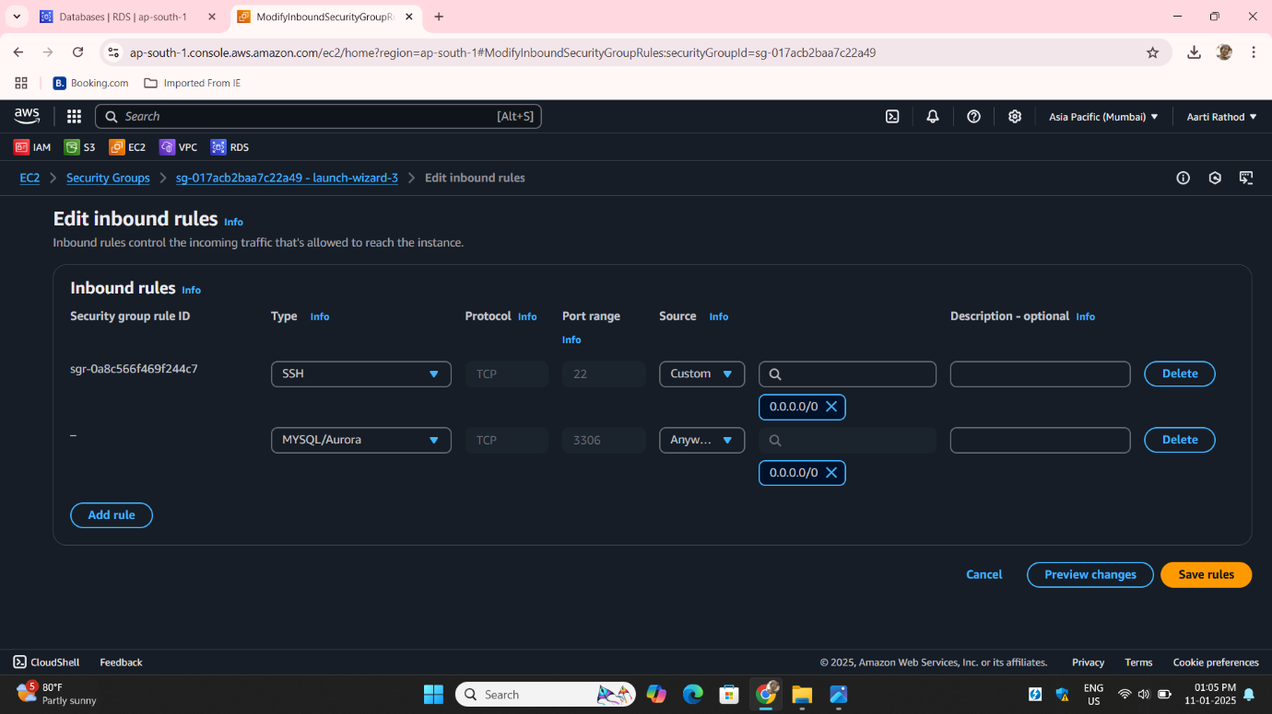

**Step21**: Configure **RDS Security Group** Access Security Groups:

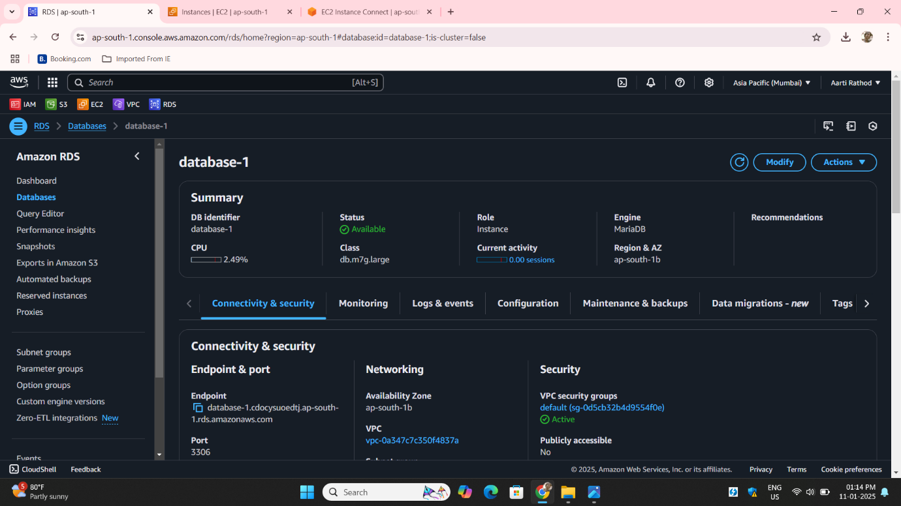

**Step23: Add a Rule for MySQL/Aurora:**

Click **Add Rule**.

Configure the rule as follows:

**Type:** MySQL/Aurora (3306)

**Protocol:** TCP

**Port Range:** 3306

**Source:** Anywhere

Click **Save Rules** to apply changes.

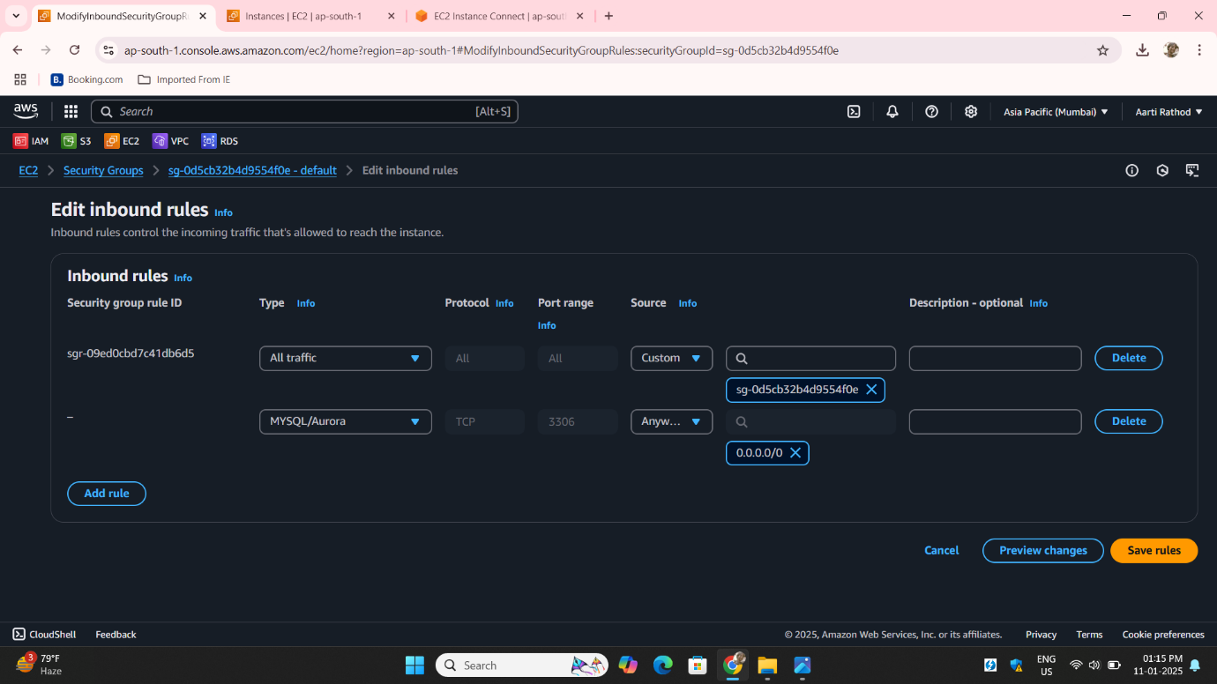

**Step24:** Come to ec2 instance select instance click on connect:

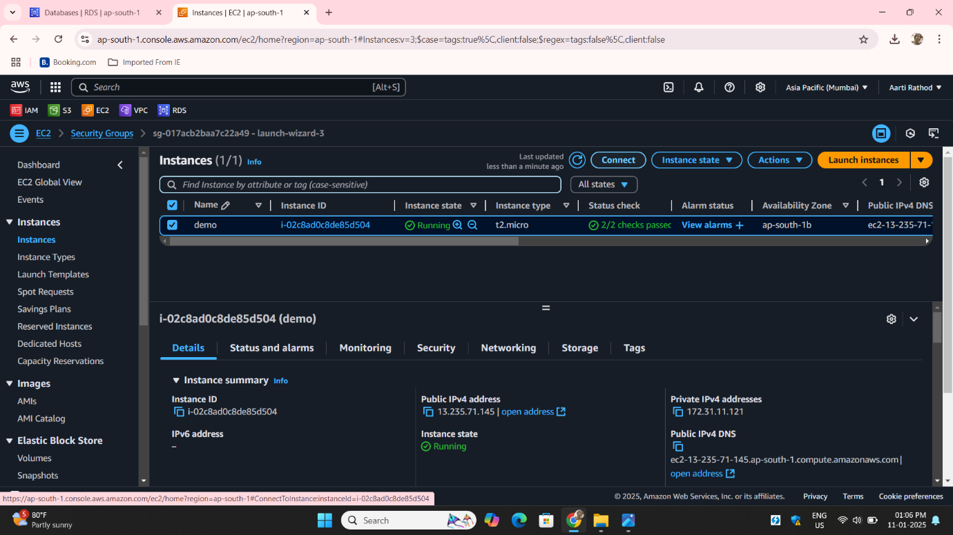

**Step25: Install MariaDB Client:**

Run the yum command to install **MariaDB** client:

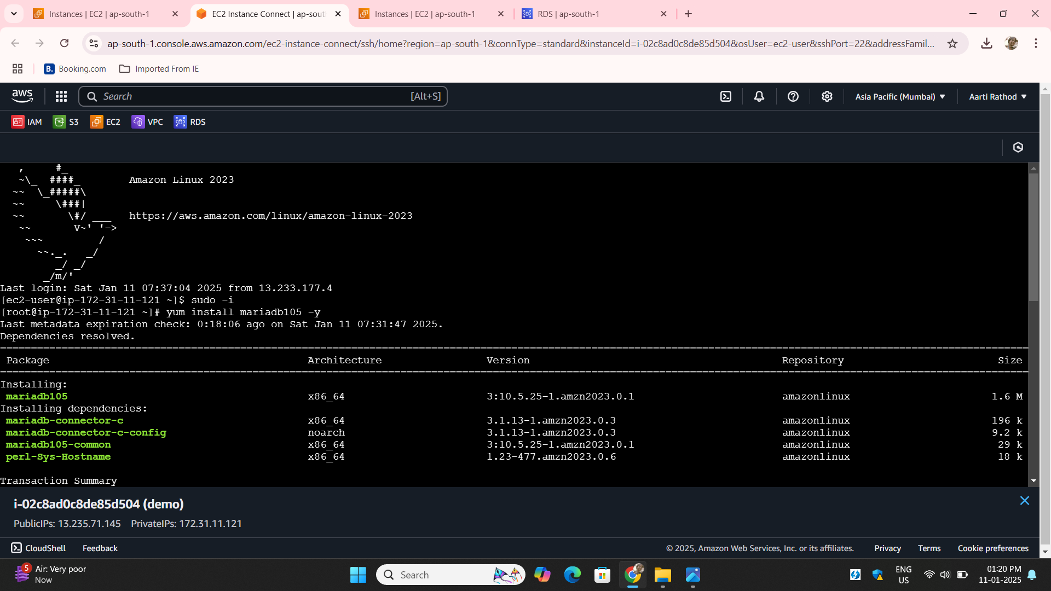

**Step26: Connect to mariaDB With** **RDS Endpoint:** Use the RDS endpoint, username, and password you set while creating the RDS instance:

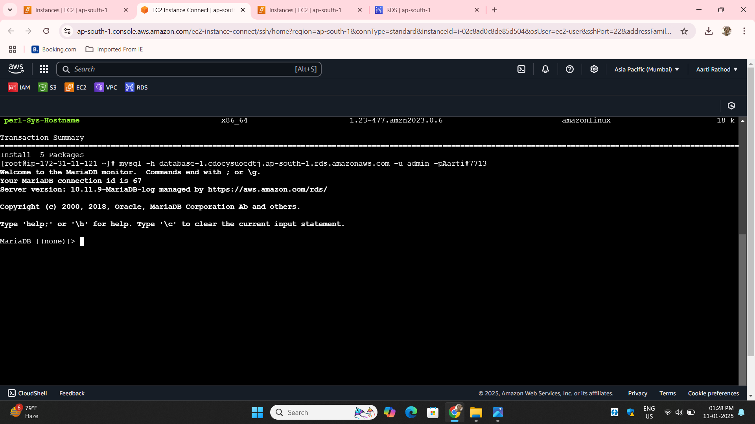

**Step27: Run Some Command For Database Create And Access**:

**Show databases-** check databases

Create one database give **name matfly**

Create a database and test the connection:

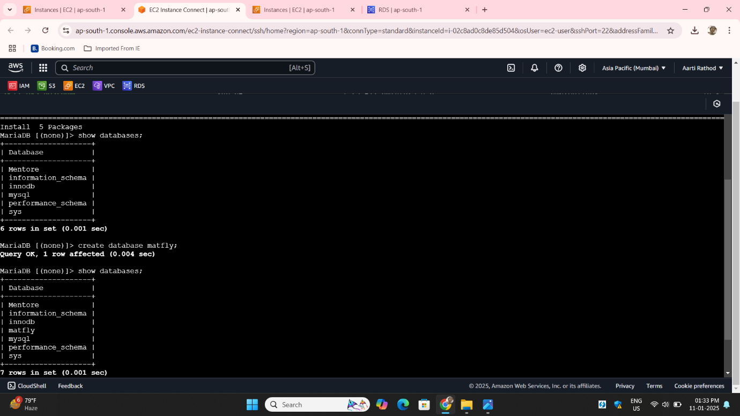

**Step28: Use matfly** command to write inside database

Create table **Employees**

Insert into **Employees:**

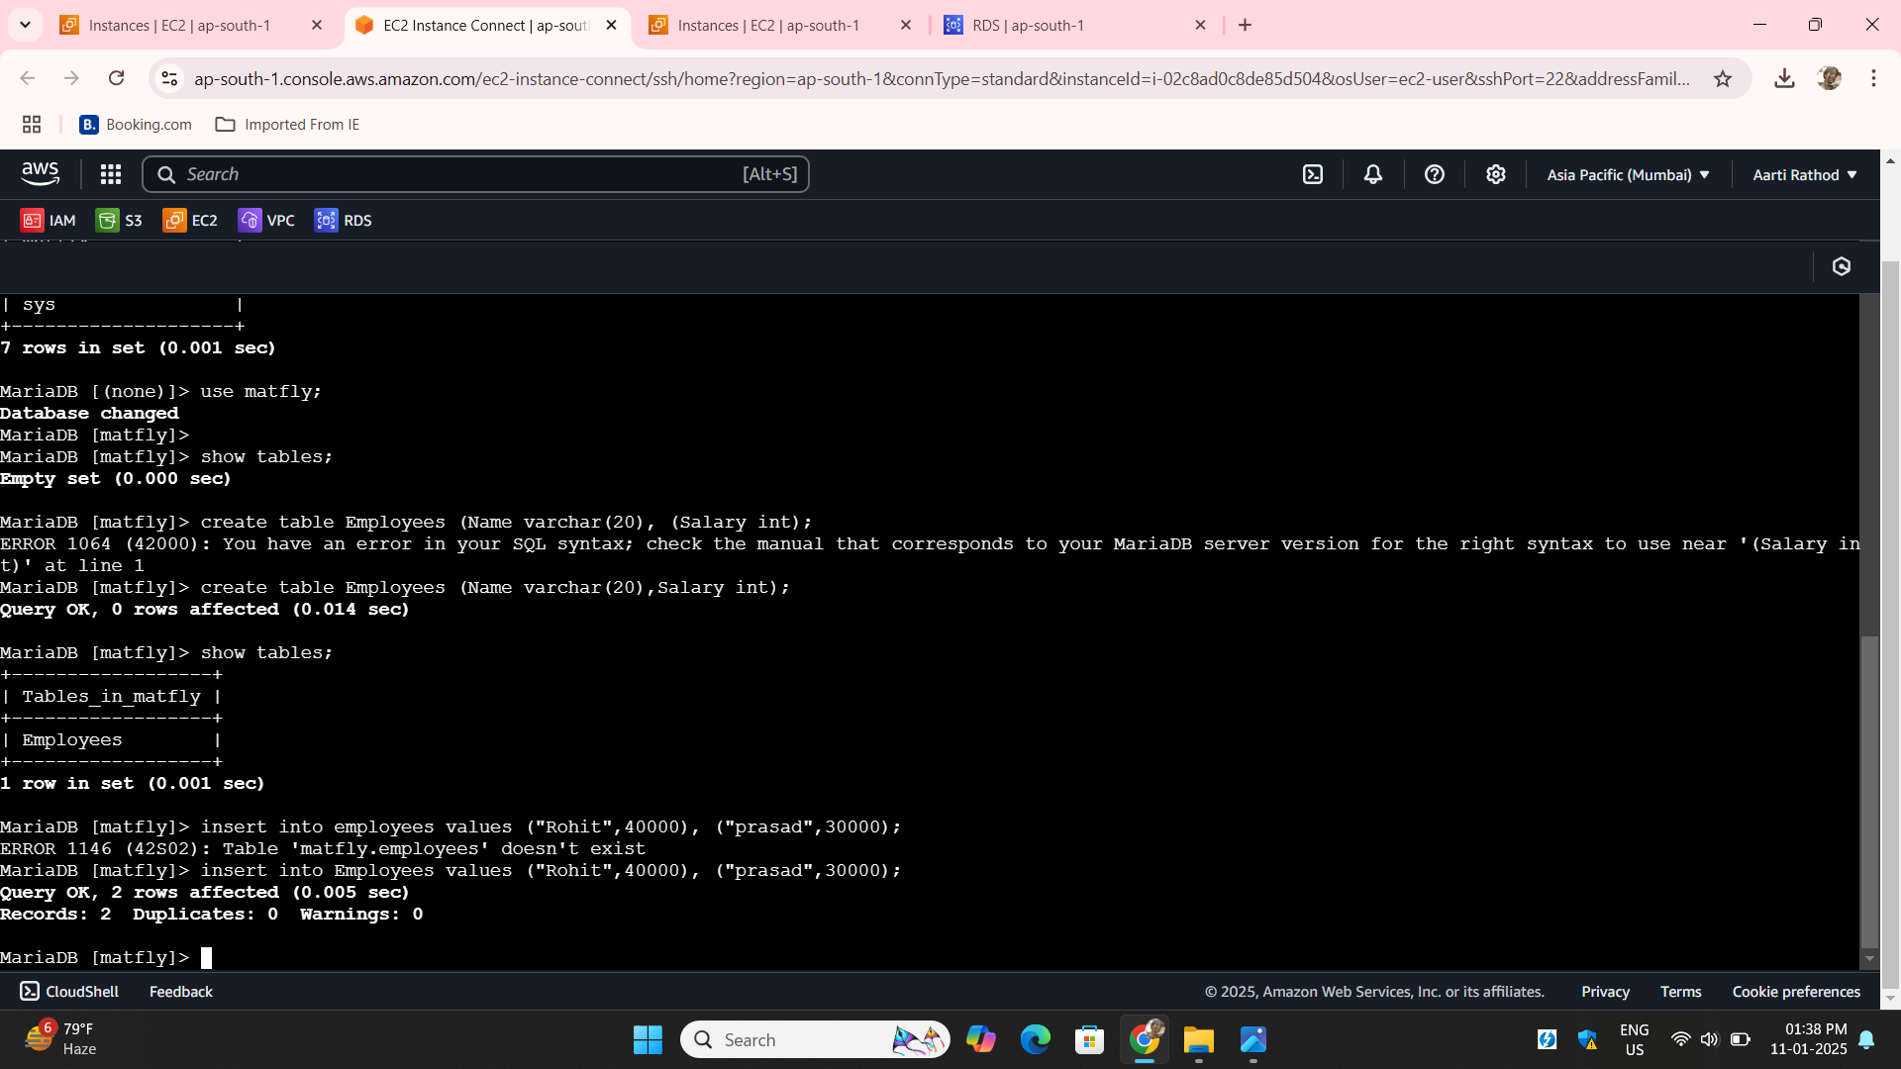

**Step29**: Check the data with command **select * from Employees:**

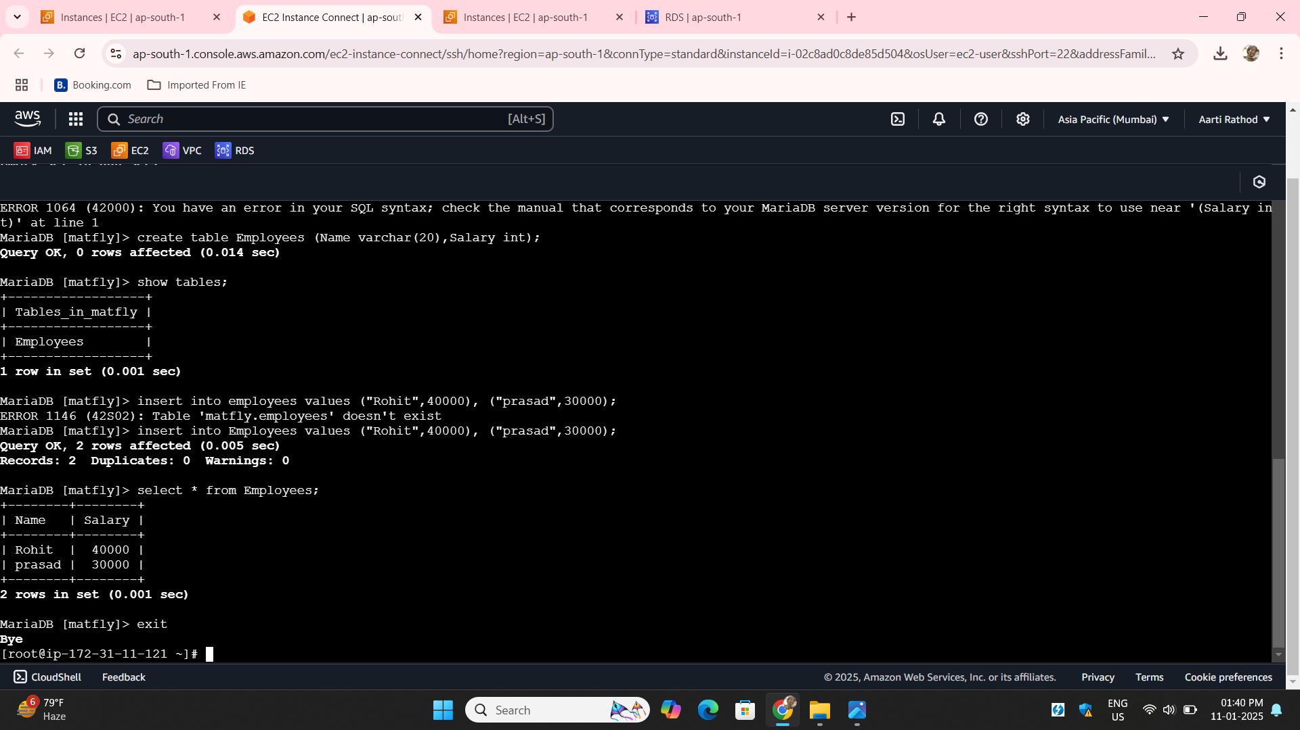

**Step30**: Take backup of the database with **mysqldump command:**

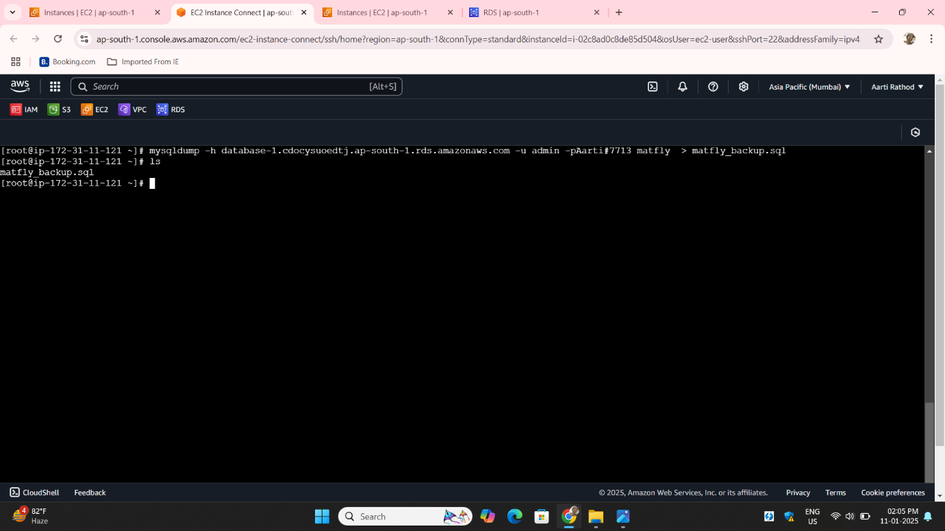

**Step31: Launch** another instance for creating database locally **demo2**:

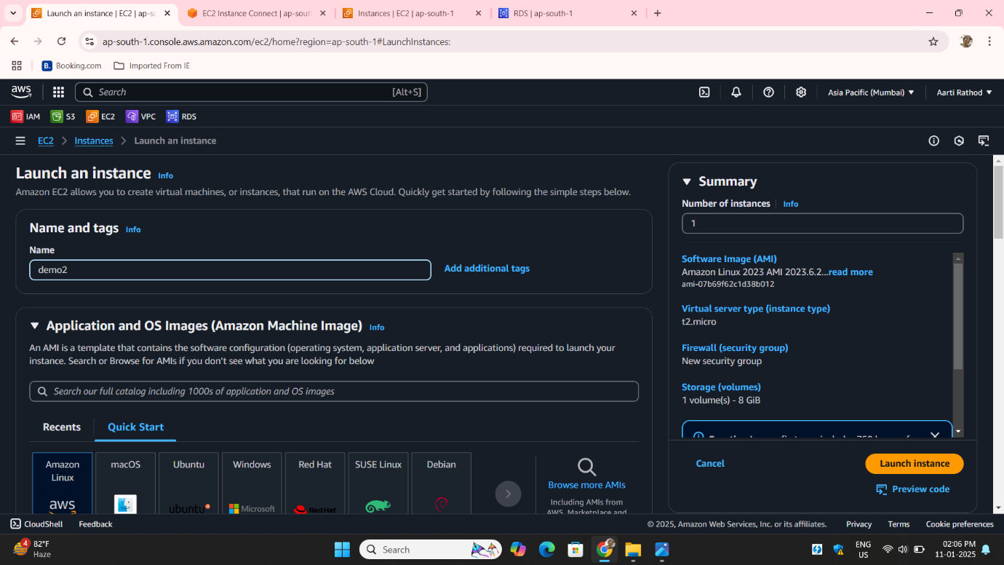

**Step32**: Attach **key pair And launch instance:**

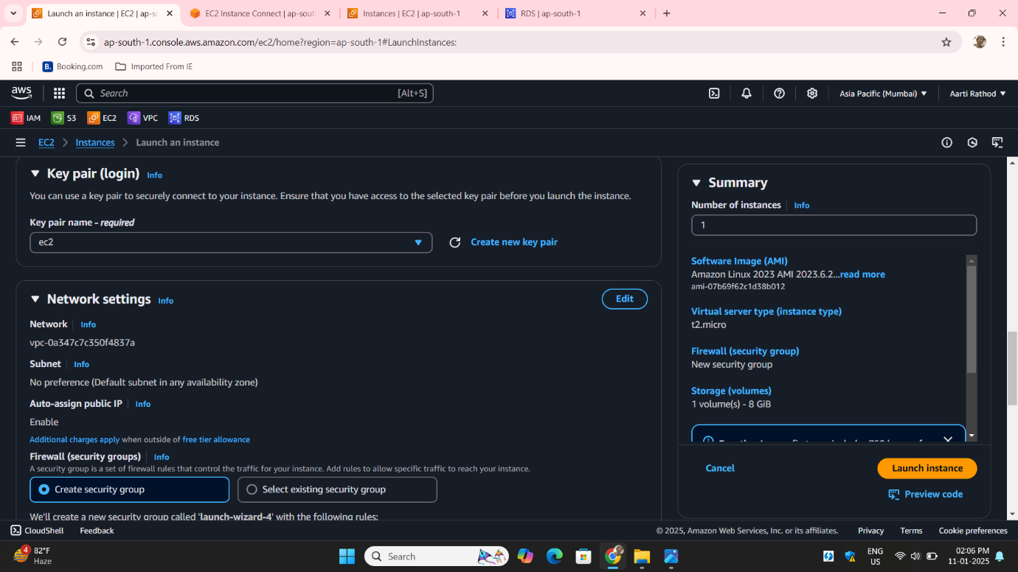

**Step33**: Go to **security group** edit **inbound rules** allow port **3306:**

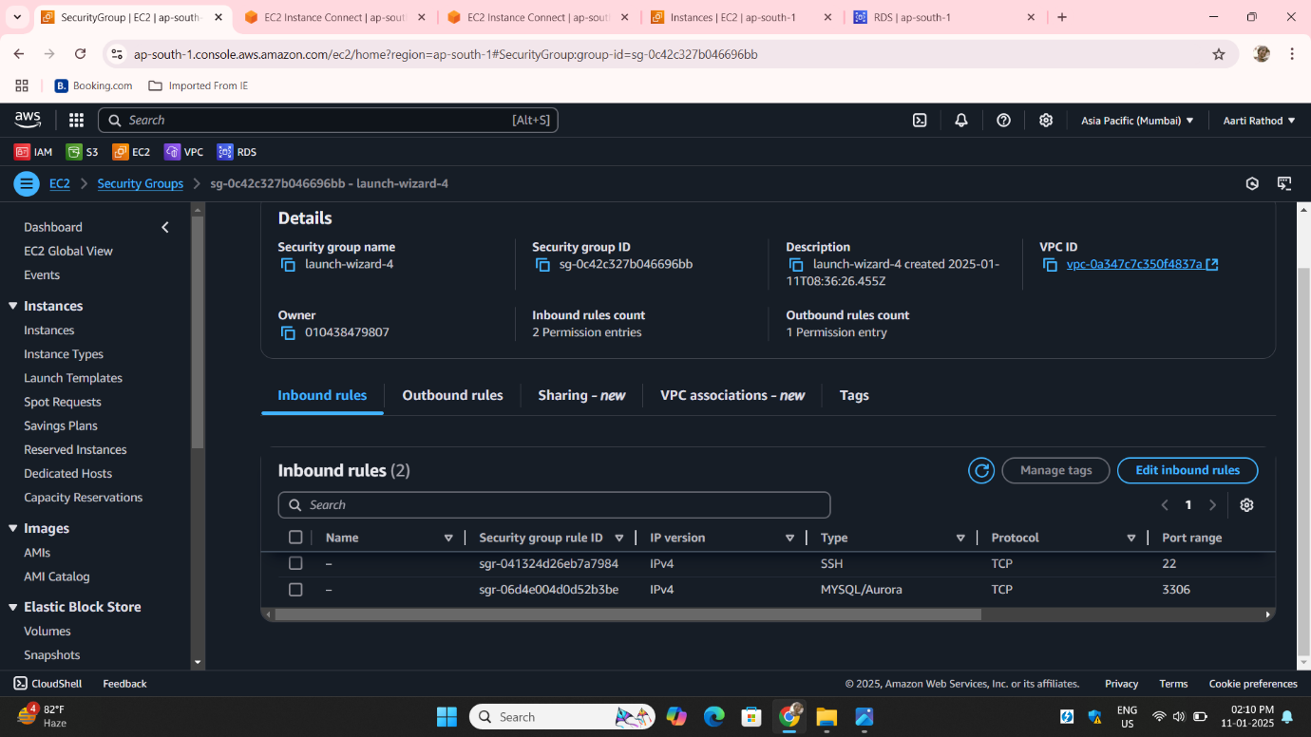

**Step34**: Connect that **demo2** instance on **MobaXterm** switch to root using **sudo –i** command

**Install mariadb Start mariadb**

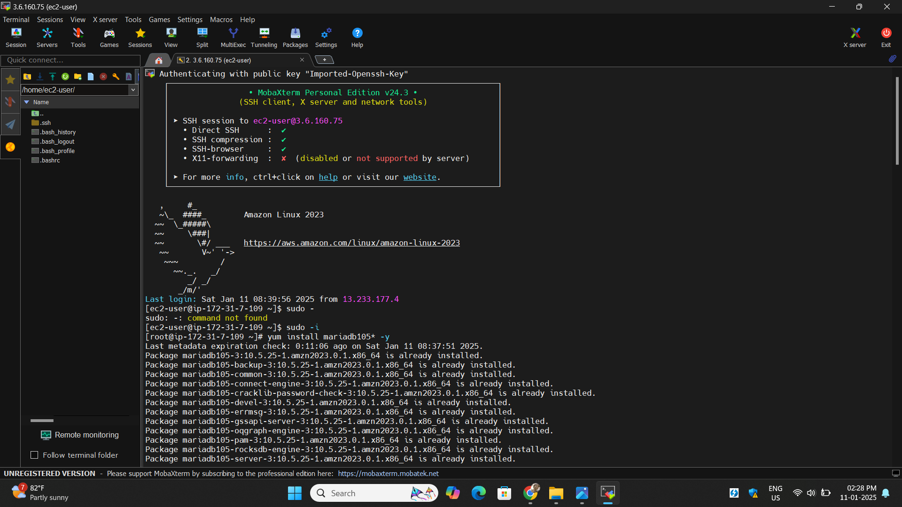

**Step35**: Start **secure installation** Set **new password** :

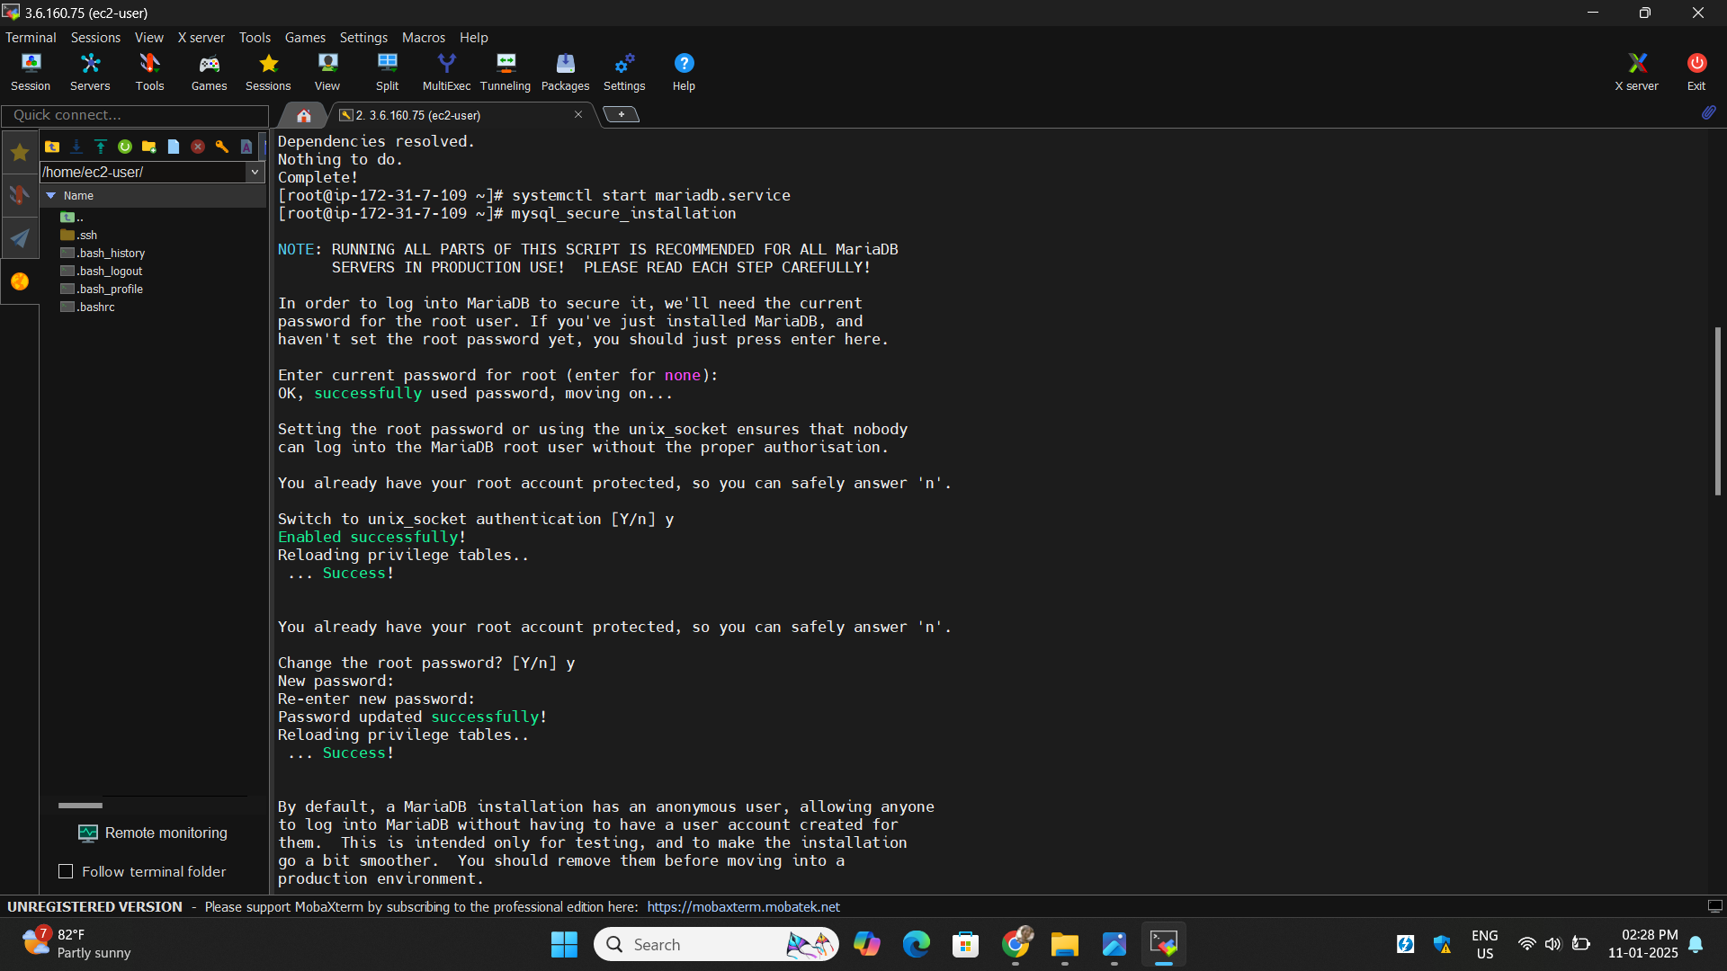

**Step36**: Access local **mariaDB** create database **student**

Create table **demo** insert some data and exit the **mariaDB:**

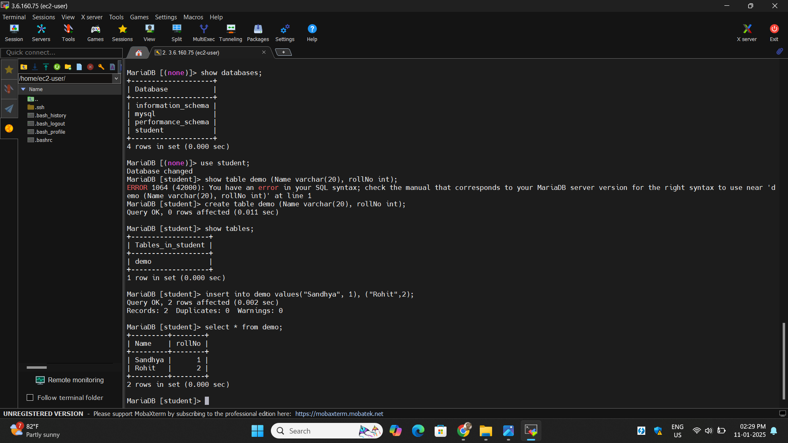

**Step37**: Create **backup** with **mysqldump** command Dumpthe local database to a **.sql file:**

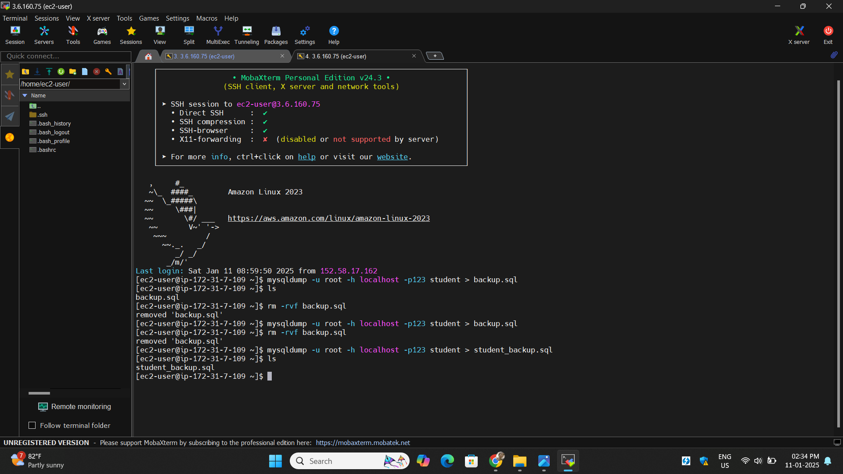

**Step38**: Import the backup to **RDS:**

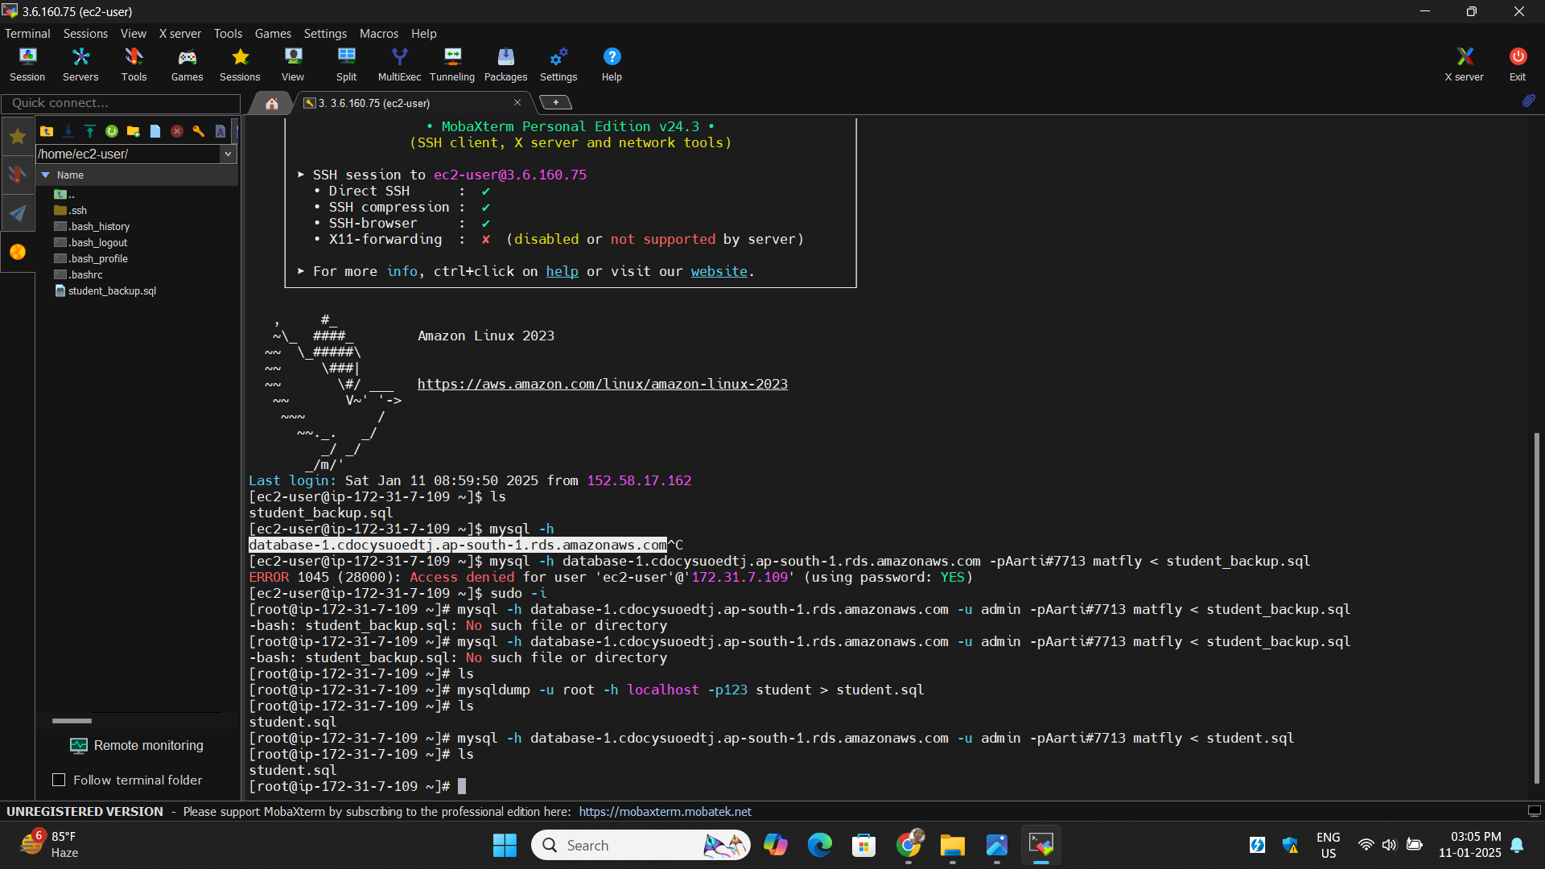

**Step39**: Connect the **RDS** again with **endpoint** Run the command **show tables** :

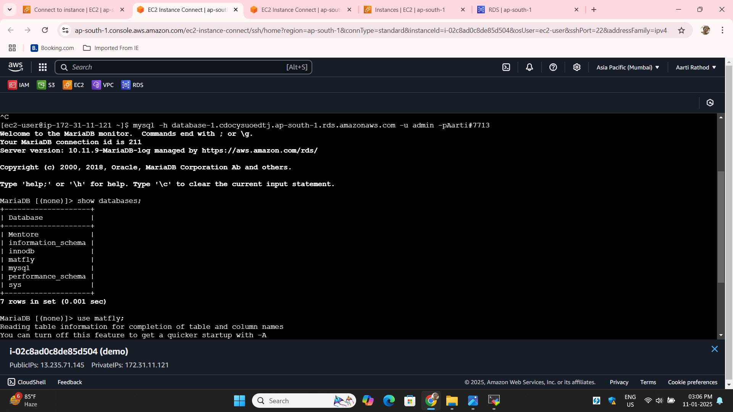

**Step40**: Here you can see the table which we have created **in locally on ec2 instace** this is how we can take **back up** :

